FULL-STACK PROJECT REPORT FILE

(2020-2021)

On

**SAARTHI**

**Submitted by**

**Vinay Kumar** (**181500793**)

**Yash Mathur** (**181500825**)

**Rachit** (**181500523**)

Department of Computer Engineering & Applications

**Institute of Engineering & Technology**



**GLA University**

**Mathura- 281406, INDIA**

**2020**

**Acknowledgement**

When I am writing this project, my mood was good because of the topic title I choose, make me interested with what I am writing in this project and research I conducting up to the time If in this project, in the point that now a days the world demand mostly on e-commerce activities in conducting business and online transaction growth everyday as now we are in science and technology century.

I would like to express my special thanks of gratitude to my instructor Mr. Pankaj Kapoor for the support and help he gave me towards the completion of this project, most of time their videos corrected me where I was wrong, guide me where necessary, it’s so helpful for me and good to working with him.

I wish to thank my all teammates for their great contribution daily in this project. We meet in the class and outside the class on which area is important in project, how to write it and also helping each other towards the completion of this project is so helpful because sometime we forget necessary research on this project.

I wish to thank my family and outside friends for the encouragement and motivation towards the completion of this project, is so helpful, first my family for financial matter, and outside friends for supporting each other day until now I am writing my final year project.

Lastly, I am really thankful for all I mention above and others who helped me a lot in finishing this project within the limited time.

**Certificate**

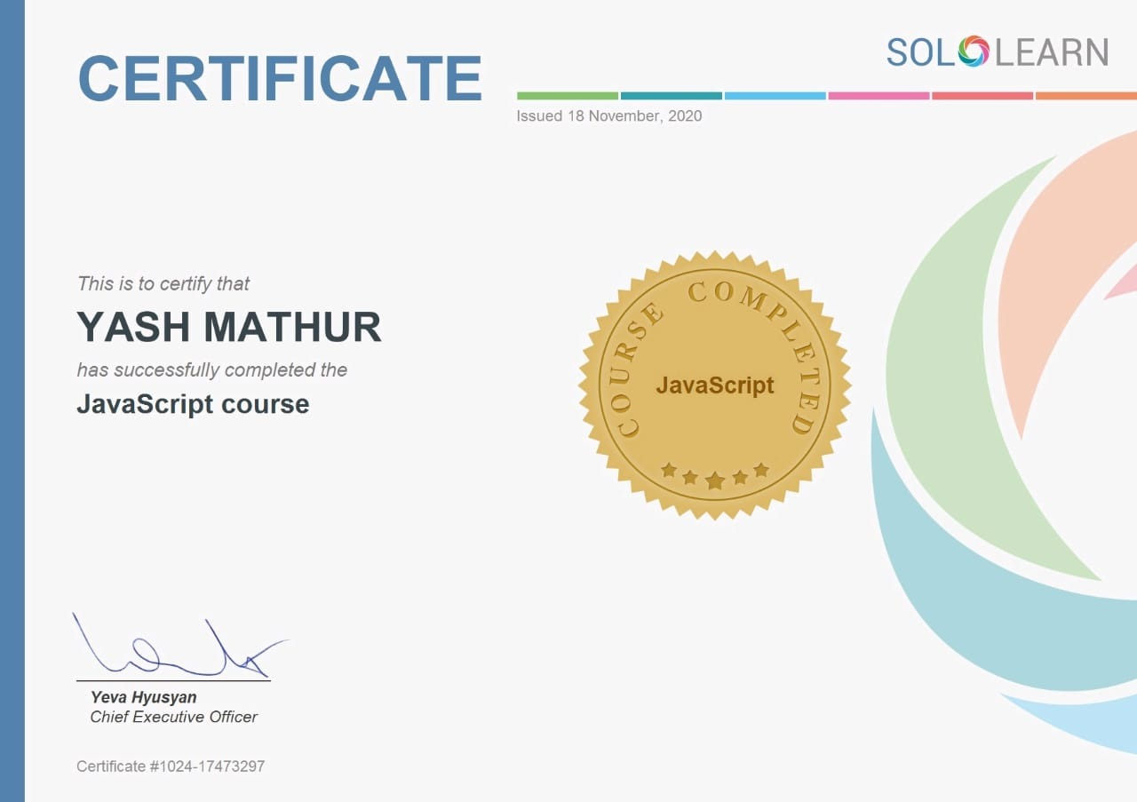

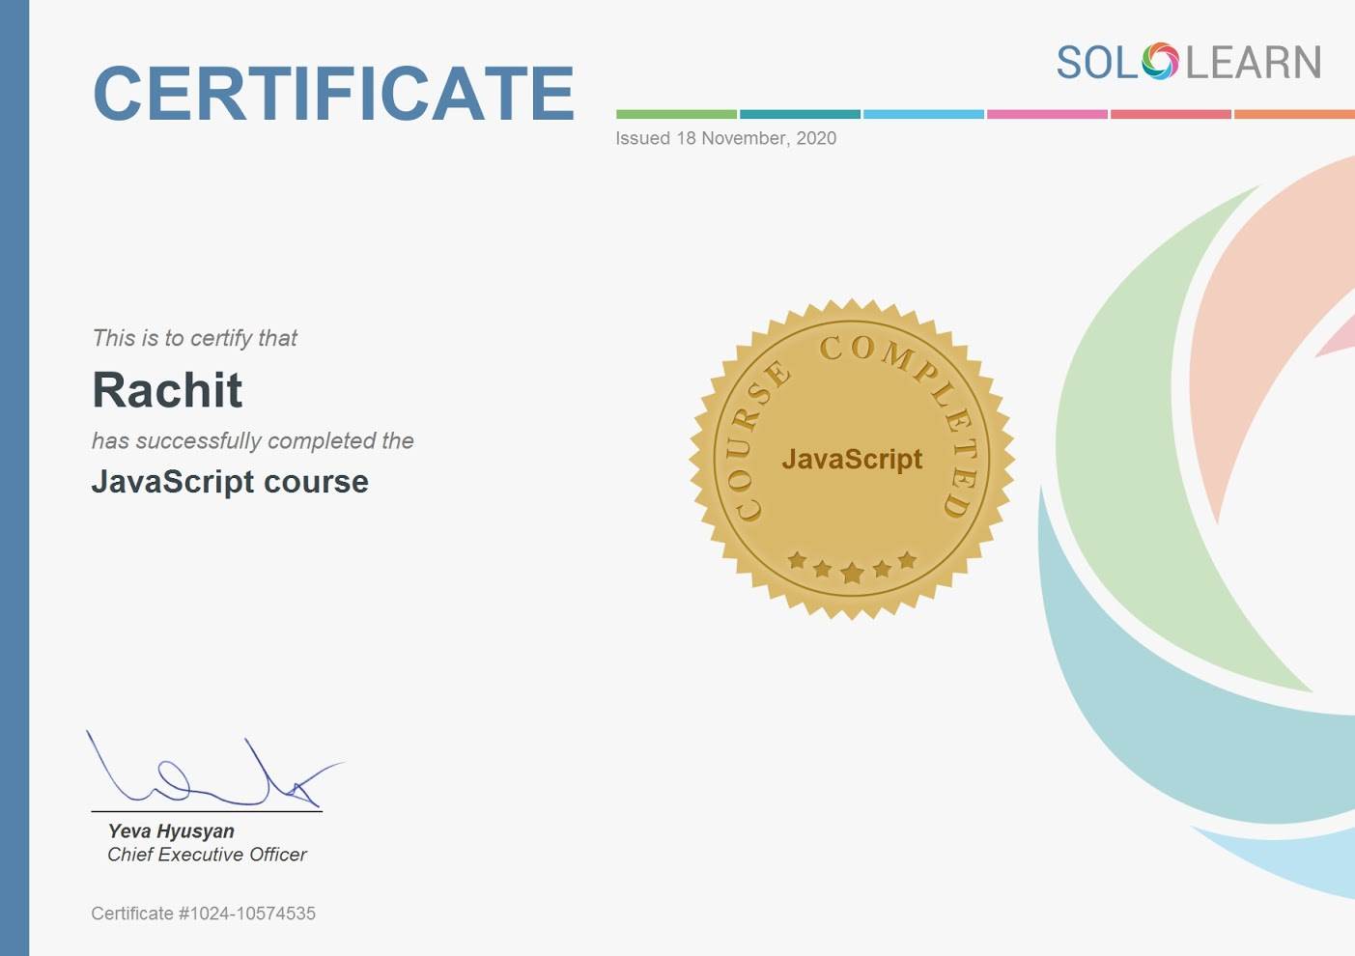

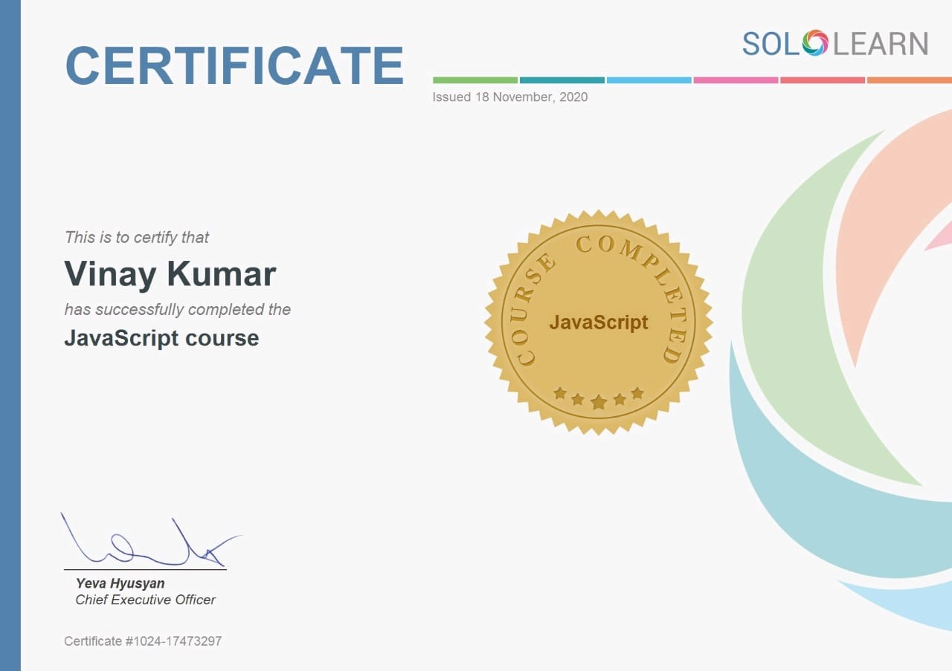

**Abstract**

Natural calamities are not the new events they are since the beginning of earth and almost every civilization has faced it. In ancient times people believes that it was due to god’s anger but in today’s world technology is so advanced we know the actual reason behind these calamities the only thing we must know is how to save ourselves from these calamities and our project ‘SAATHI’ a website which will help others to take necessary steps while dealing with these events.

**Table of Contents**

**1)Introduction - 8**

**a) Introduction to project**

**b) Problem statements**

**c) Project scope**

**2) System specifications - 10**

**a) hardware requirements**

**b) software requirements**

**c) Technology used**

**4) Testing - 14**

**a) Gantt Chart**

**b) Objective of Testing**

**5) Screenshots - 17**

**Introduction**

**Introduction of the project:**

A Natural disaster is an unforeseen occurrence of an event that causes harm to society. There are manynatural disasters that damage the environment and the people living in it. Some of them areearthquakes, cyclones, floods,tsunami landslides, volcanic eruption, and avalanches. The destructive potential of any natural hazard is estimated basically by its spatial extent and severity. Spatial extent up to which the effect of a disastrous event could be felt may easily be classified into small, medium and large scales. The phenomenon extending from a few kilometres to a few tens of kilometres are termed as small scale.

Growing industrialisation and unjustified exploitation of natural resources have brought our echo system to a verge of non-reversibility and imbalance. This has led to a threat from a set of natural hazards like pollution, global warming and ozone depletion on large or global scale.

They can occur at any place and at any time some of these are predictable while others are not so it is very important for us to stay safe while dealing with these calamities. This website provides details about various factors like how different calamities occurs, what are the necessary steps to be taken while dealing those calamities and lot more. In today’s era we are rich in technology we must use it so by taking advantage of this technology we have prepared this website and website is a best way to share thoughts and ideas because content on it can be accessible by any device.

**Problem Statement:**

This project is to create a website having detailed information regarding natural calamities. Detailed information includes the best scientific reason for the occurrence of a particular calamity, necessary steps to be taken during these calamities etc. The project should be very easy to use enabling a novice person to use it.

**Project Scope:**

* The website holds crystal correct information for any calamity that is available on this website.
* Website interface is very simple even a novice user can use it.
* High definition images and designs have been used in this website so user can get good understanding of content.

**System Specification**

In hardware requirement we require all those components which will provide us the platform for the development of the project. The minimum hardware required for the development of this project is

as follows-

● Ram- minimum 128 MB

● Hard disk—minimum 5 GB

● Processor- Pentium 3

These all are the minimum hardware requirement required for our project. We want to make us

project to be used in any type of computer therefore we have taken minimum configuration to a

large extent. 128 MB ram is used so that we can execute our project in a least possible RAM.5 GB hard disk is used because project takes less space to be executed or stored. Therefore, minimum hard disk is used. Others enhancements are according to the needs.

**Software Requirements:**

Software’s can be defined as programs which run on our computer .it act as petrol in the vehicle. It provides the relationship between the human and a computer. It is very important to run software to function the computer. Various software’s are needed in this project for its development.

● Operating system—Windows 7 OR ANY VERSION >6, or any Linux operating system

● Editor Software—Visual Studio

● Testing Software---- google chrome (or any web browser)

**Technology Used:**

1. **Html:**

**HTML** stands for **Hypertext Mark-up Language**. It allows the user to create and structure sections, paragraphs, headings, links, and blockquotes for web pages and applications.HTML was invented by [Tim Berners-Lee](https://en.wikipedia.org/wiki/Tim_Berners-Lee), a physicist at the CERN research institute in Switzerland. He came up with the idea of an Internet-based hypertext system.

Hypertext means a text that contains references (links) to other texts that viewers can access immediately. He published the first version of HTML in 1991, consisting of 18 HTML tags. Since then, each new version of the HTML language came with new tags and attributes (tag modifiers) to the mark-up.

1. **CSS:**

Cascading Style Sheets is a style sheet language used for describing the presentation of a document written in a mark-up language such as HTML. CSS is a cornerstone technology of the World Wide Web, alongside HTML and JavaScript. The saga of CSS starts in 1994. Håkon Wium Lie works at CERN – the cradle of the Web – and the Web is starting to be used as a platform for electronic publishing. One crucial part of a publishing platform is missing, however: There is no way to style documents. For example, there is no way to describe a newspaper-like layout in a Web page. Having worked on personalized newspaper presentations at the MIT Media Laboratory, Håkon saw the need for a style sheet language for the Web.

Style sheets in browsers were not an entirely new idea. The separation of document structure from the document's layout had been a goal of HTML from its inception in 1990. Tim Berners-Lee wrote his NeXT browser/editor in such a way that he could determine the style with a simple style sheet. However, he didn't publish the syntax for the style sheets, considering it a matter for each browser to decide how to best display pages to its users. In 1992, Pei Wei developed a browser called Viola, which had its own style sheet language.

1. **JavaScript:**

JavaScript, often abbreviated as JS, is a programming language that conforms to the ECMAScript specification. JavaScript is high-level, often just-in-time compiled, and multi-paradigm. It has curly-bracket syntax, dynamic typing, prototype-based object-orientation, and first-class functions. The early to mid-1990s was an important time for the internet. Key players like Netscape and Microsoft were in the midst of browser wars, with Netscape’s Navigator and Microsoft’s Internet Explorer going head to head.

In September 1995, a Netscape [programmer](https://www.springboard.com/blog/programmer-portfolio/) named [Brandan Eich](https://en.wikipedia.org/wiki/Brendan_Eich) developed a new scripting language in just 10 days. It was originally named Mocha, but quickly became known as LiveScript and, later, JavaScript.

JavaScript is everywhere, and for the seventh year in a row, it has been ranked [the most commonly used programming language](https://fossbytes.com/javascript-most-popular-programming-language-stack-overflow/), with 67.8% of developers employing it in 2019. Its ascent to the world’s most popular programming language is synonymous with the rise of the internet itself.

Created out of necessity, it is used to build 95.2% (1.52 billion) of websites today, including some of the world’s largest, like Facebook and YouTube. Without it, we would not have popular and useful web apps such as Google Maps and eBay.

So, without further ado, let’s take a look at what JavaScript is, how and why it was created, and what’s next for the language.

**Testing**

**Gantt Chart**

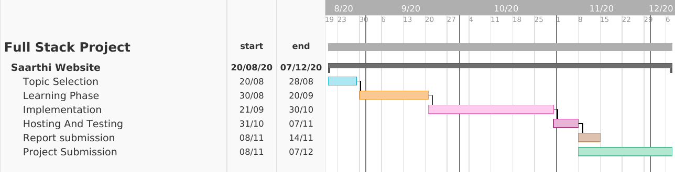

**Objective of Testing:**

The important objectives of system testing are to make system defect less/perfect so that it works properly in any condition means it satisfy all conditions and work for all input.

System testing: simulates real life scenario that occur in a simulated real-life test environment, and tests all functions

of the system that are required real life System testing is deemed complete when actual results and

expected results are either inline or differences are explainable or acceptable, based on client input.

**UNIT TESTING:**

Unit testing is a software development process in which the smallest testable parts of an application, called units, are individually and independently scrutinized for proper operation. Unit testing is often automated but it can also be done manually. This testing mode is a component of Extreme Programming (XP), a pragmatic method of software development that takes a meticulous approach to building a product by means of continual testing and revision.

**INTEGRATION TESTING**:

Integration testing is a logical extension of unit testing. In its simplest form, two units that have already been tested are combined into a component and the interface between them is tested. A component, in this sense, refers to an integrated aggregate of more than one unit. In a realistic scenario, many units are combined into components, which are in turn aggregated into even larger parts of the program. The idea is to test combinations of pieces and eventually expand the process to test your modules with those of other groups. Eventually all the modules making up a process are tested together. Beyond that, if the program is composed of more than one process, they should be tested in pairs rather than all at once.

**ACCEPTANCE TESTING:**

User Acceptance Testing is often the final step before rolling out the application. Usually the end users who will be using the applications test the application before ‘accepting’ the application. This type of testing gives the end users the confidence that the application being delivered to them meets their requirements. This testing also helps nail bugs related to usability of the application.

1. Some Blogs

2. GitHub

**Screenshots**

